How Updates Work
GPTK Library Manager includes a built-in auto-updater that checks for new versions automatically. You don't need to download anything manually — the app handles everything for you.
Step 1: Update Available Notification
When a new version is available, you will see a notification banner in the app.
- The banner shows the new version number and download size.
- Click "Download" to start downloading the update.
Note: You can continue using the app normally while the update downloads in the background.


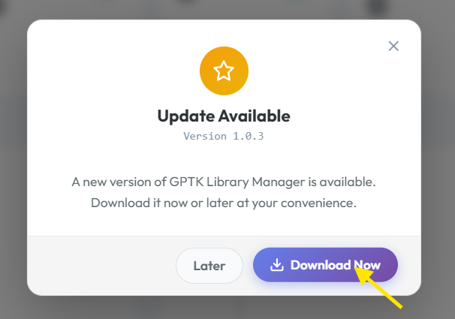
Step 2: Downloading the Update
- A download progress bar will appear showing:
  - Percentage completed
  - Downloaded / Total size (e.g., "15.2 MB / 89.4 MB")
  - Download speed
- You can click "Cancel" to stop the download at any time.
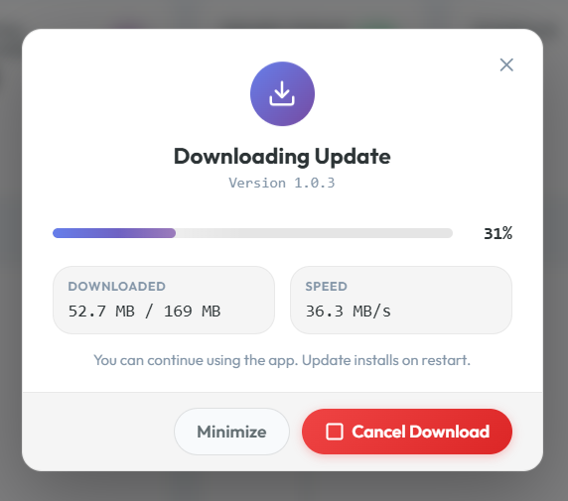
Step 3: Ready to Install
Once the download is complete:
- An "Install Now" button will appear.
- Save any unsaved work before clicking Install.
- Click "Install Now" to begin the installation.
Important: The app will close during installation. Make sure to save all your work before proceeding.
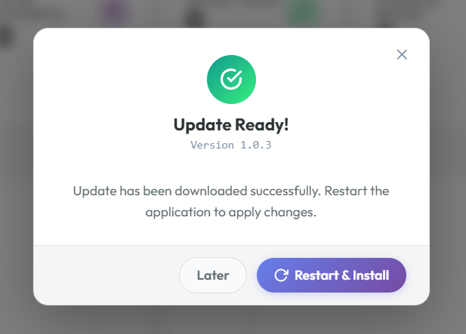
Step 4: Installation Overlay
After clicking "Install Now":
- An in-app overlay will appear with the message:
"Installing v1.0.3... The app will reopen automatically."
- A Windows toast notification will also appear as a reminder.
- The app will close after a few seconds.
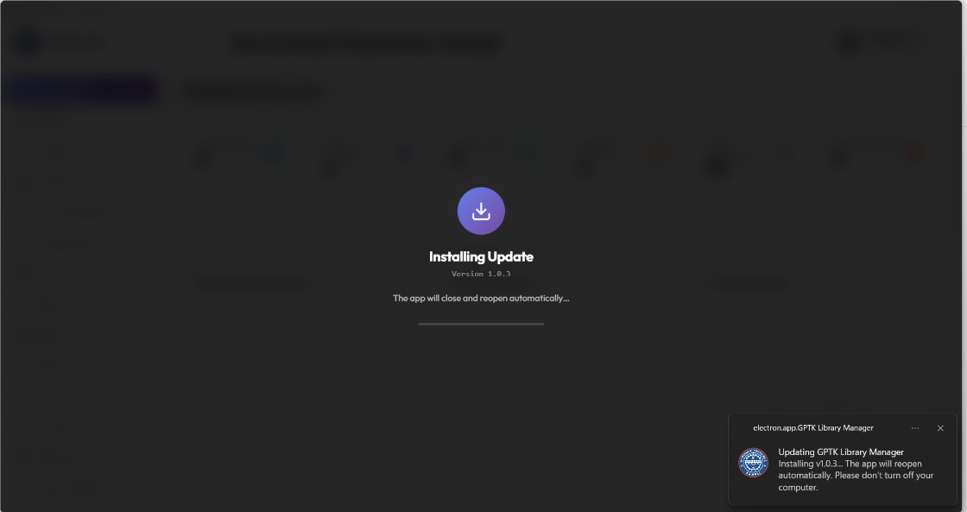
Step 5: NSIS Installer Progress
After the app closes, the NSIS installer will open automatically:
- The installer will show only the "Updating..." progress bar — no other pages.
  - Header: "Updating GPTK Library Manager"
  - Subtitle: "Please wait while the update is being installed..."
- Files are being extracted and replaced in the background.
- Do not close this window or shut down your computer.
Note: During updates, the installer skips the Welcome, Installation Options, and Directory pages. It goes straight to the progress bar using the same settings as your original installation.
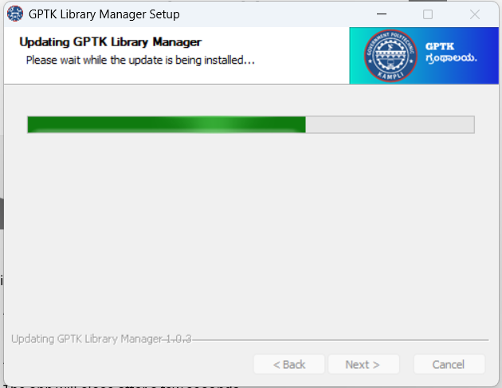
What is preserved during updates:
Item | Preserved?
Installation location | ✅ Yes
Install type (All Users / Current User) | ✅ Yes
Database & records | ✅ Yes
Settings & preferences | ✅ Yes
Local backups | ✅ Yes
Desktop shortcut | ✅ Yes
Start Menu shortcut | ✅ Yes
Step 6: App Reopens with Changelog
- After the update completes, the app automatically reopens.
- A changelog dialog will appear showing:
  - New version number
  - What's new (new features, bug fixes, improvements)
- Click "OK" or close the dialog to continue using the app.
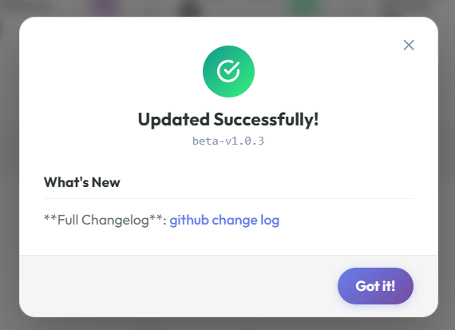
Troubleshooting
Issue | Solution
Update notification doesn't appear | Go to Settings → click "Check for Updates" manually
Download fails or stalls | Check your internet connection and try again. Click "Cancel" then "Download" again
Installation seems stuck | Wait at least 2–3 minutes. The progress bar may appear slow for large updates
App doesn't reopen after update | Find GPTK Library Manager in the Start Menu and launch it manually
Update installs but old version shows | Try restarting the app. If the issue persists, check Settings → About for the version number
"Another instance is running" error | Close all GPTK Library Manager windows (check the system tray) and try again
Changelog doesn't appear | The update was successful. Check Settings → About to confirm the new version
Comparison: Fresh Install vs Update
Installer Page | Fresh Install | Update
Welcome page | ✅ Shown | ❌ Skipped
Installation options | ✅ Shown | ❌ Skipped (reuses previous)
Directory selection | ✅ Shown | ❌ Skipped (reuses previous)
Installing / Updating progress | ✅ Shown | ✅ Shown
Finish page | ✅ Shown | ❌ Skipped (auto-reopens app)
Log File
If you encounter issues during or after an update, the application writes detailed logs to:
%APPDATA%\gptk-library-management-system\logs\main.log
You can find this path on the System Health page → Report a Bug section → click "Copy Path".
Include this log file when reporting issues on GitHub for faster diagnosis.
For more help, visit the System Health page in the app and click "Report Bug on GitHub".

